PREDSTAVITVENI NASTOP DRUŠTVA SE IZVAJA V OKVIRJU VSESLOVENSKEGA TEDNA LJUBITELJSKE KULTURE S PODPORO JSKD
IN LJUBLJANSKEGA GRADU

PRIREJA DNE 22.06.2014 OB 17 URI NA
LJUBLJANSKEM GRADU PREDSTAVITVENI NASTOP
VSEH AKTIVNIH SKUPIN DRUŠTVA

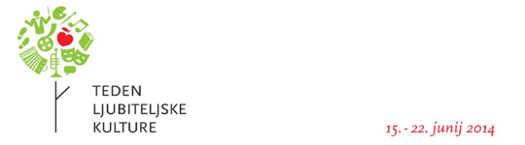



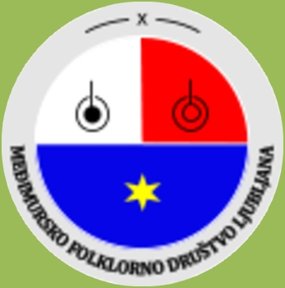

7. LITERARNO DRAMSKA SKUPINA
(LITERARY DRAMA GROUP)
RECITACIJA - VESNA VURUŠIČ
(RECITAL BY VESNA VURUŠIČ)
- Internat(Boarding school)

8. IVEK LESKOVAR – NA TAMBURICI
(IVEK LESKOVAR PLAYING THE TAMBOURA)
- Venček starosplitskih pesmi
(-a medley of old songs from Split)

9 . (MUSIC GROUP)
- nekaj za dušo ( Some Soul Food)
- (O sole mio )

10. LITERARNO DRAMSKA SKUPINA
(LITERARY DRAMA GROUP)
DRAMSKA IGRA: Trsek moj
(a short play titled ”Trsekmoj”: My Little Grapevine)

11. SKUPNA ZAKLJUČNA PESEM
(A GROUP FAREWELSONG)
- Nocoj je ena lušna noč(Tonight is a wonderful
night)

4. FOLKLORNA SKUPINA : SPLET MEĐIMURSKIH PLESOV
(THE FOLKLORE GROUP: A SET DANCES OF MEĐIMURJE)
- Trlja(Flax-brake)

SKUPINA ROČNIH DEL ( HANDICRAFTS SECTION )

5. LITERARNO DRAMSKA SKUPINA
- recitacija ANA (Antonija Baksa-Srnel) DE SAM
- recitacija FERI (Tin Ujevič) SVAKIDAŠNJA JADIKOVKA
(LITERARY DRAMA GROUP RECITAL BY ANA and FERI

6. GLASBENA SKUPINA :DUO GREGOR IN JANKO
(MUSIC GROUP : DUO GREGOR &JANKO)
-Over the Rainbow
-Pesem ptic trnovk (The Thorn Birds)

NASTOPAJOČI: ( PERFORMERS : )
1.PEVSKA SKUPINA FIJOLICE
(VOCALGROUP VIOLETS)
-Sinoči sem na vasi bil
(I was in the village lastnight)
-Snočka sam ti kesnofučkal i popeval
(I waswhistlingandsingingforyou late last night
2. LITERARNO DRAMSKA SKUPINA
(LITERARY DRAMA GROUP)
METKA OSOJNIK: RECITACIJA
(RECITAL BY METKA OSOJNIK)
-Prijatelju
(To a friend)
-Zdaj spet živim
(Now I Live Again)

3. MARUŠA NA CITRAH
(MARUŠA PLAYING THE ZITHER)
-Kadar pa mimo hiše grem
(When I pass the house)
-Zlatolaska
(Goldilocks)
-Gozdovi v mesečini
(The woods in the moonlight)

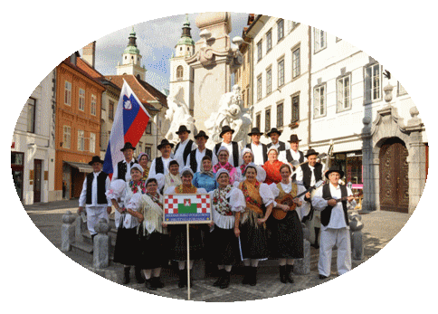



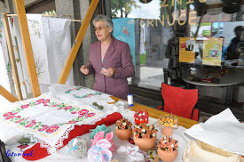
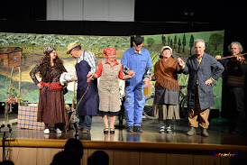
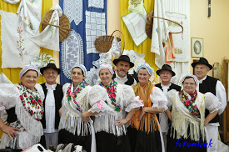

WHO ARE WE ?
We are the Međimurje Folklore Society Ljubljana. For those of you, who do not know where Međimurje is; it is the northernmost Croatian county and predominantly consists of plains.
Lying between the rivers Mura and Drava it borders Hungary in the North and Slovenia in the Northwest. The members of the Međimurje Folklore Society are of various nationalities: Croats, Slovenians, Macedonians, etc. Any fun-loving person is welcome to join us. Our society is a member of several Slovenian and Croatian associations, such as ZKDL, The Union of Slovene Folklore Groups (CIOFF), and the Croatian association HKUUMŽ. Our society was established with a goal to preserve the rich cultural and artistic heritage of Međimurje and present it in numerous appearances in Slovenia and abroad. This includes Međimurje folk dances (such as dances in circular formations - kolo dances) and folk songs, the dialect spoken in Međimurje and artefacts which were used in the old days. Aside from folk dances of Međimurje our performances also include some Slovenian dances.
KDO SMO ?
Smo Međimursko folklorno društvo Ljubljana. Za tiste, ki ne veste kje je Međimurje. To je najseve -rnejša hrvaška županija in je pretežno nižinska po-krajina. Omejujeta jo reki Mura in Drava, na severu meji z republiko Madžarsko in na severozahodu z republiko Slovenijo. Člani Međimurskega folklo-rnega društva smo različnih narodnosti Hrvati, Slovenci, Makedonci in vsak, ki je dobre volje je
dobrodošel v društvu. Društvo je včlanjeno v več slovenskih in hrvaških združenj, kot so Zveza kultu-rnih društev Ljubljana, Zveza ljudskih tradicijskih
skupin Slovenije CIOFF, ter hrvaškega združenja Zajednice hrvatskih kulturno umjetničkih
udruga međimurske županije.
Društvo smo ustanovili z namenom ohraniti
bogato kulturno in umetnostno dediščino Međimurja in jo, kot tako prikazati na številnih nastopih v Sloveniji in v tujini. Sem prištevamo međimurske ljudske plese in kola, međimurske ljudske popevke, međimursko narečno govorico in stare predmete, ki so se v starih časih uporabljali . Poleg međimurskih plesov, plešemo tudi nekatere slovenske plese.
V društvu aktivno delujejo folklorna skupina,
Literarno dramska skupina, pevska skupina, glas-
bena skupina ter skupina ročnih del.

THE PERFORMANCE WILL BE CONDUCTED AS PART OF THE AMATEUR CULTURE WEEK SPONSORED BY JSKD AND THE LJUBLJANA CASTLE

ON JUNE 22ND 2014 AT 5PM,THEMEĐIMURJE FOLKLORE SOCIETY LJUBLJANA IS STAGING A PERFORMANCE IN THE LJUBLJANA CASTLE SHOWCASING ALL ACTIVESESECTIONS OF THE SOCIETY

